95

“Big Picture” Meeting Agenda
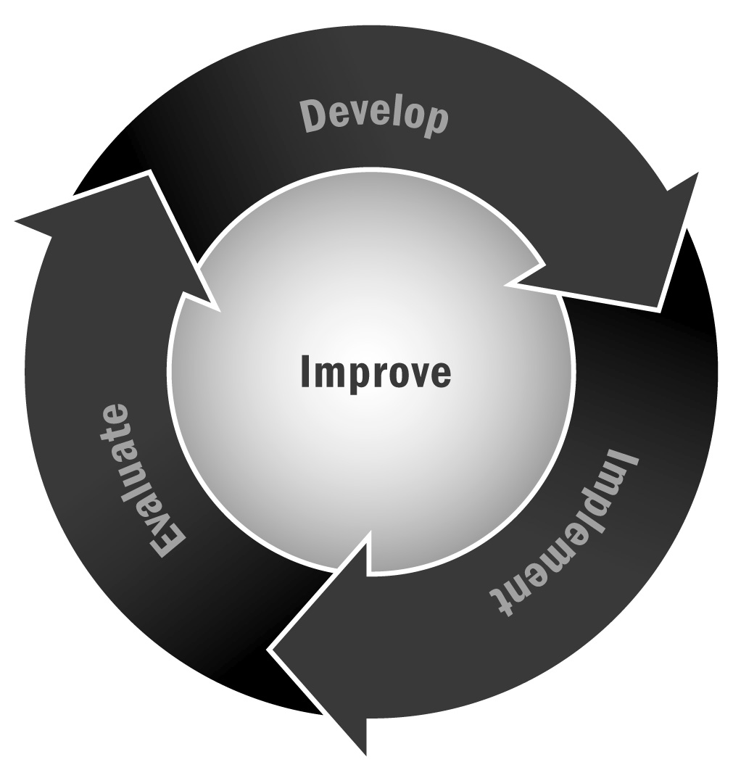
In Chapter 6, you learned about the importance of creating a culture of continuous improvement and taking the time to reflect and plan for the future. One good way to do that is to bring together a variety of stakeholders for an annual “big picture” planning meeting.
Directions: This tool provides a sample agenda (see the pages that follow) for a “big picture” planning meeting. We suggest you host a meeting like this once or twice a year. The conclusion of school-year programming can be a good time to host a meeting like this to debrief on the past year and make plans for the next one. Mid-year is also a good time to check in and adjust your course. At a minimum, we recommend that this meeting include staff members and key program providers and community partners. You may also consider inviting funders, local officials, district staff, families, and youth.

Tips for a Successful Meeting
- Plan on 2 to 2.5 hours—enough time to get things done but not so much that people start leaving to get back to their other work.
- Offer food and beverages if you can, even if they are just pastries and coffee.
- Try to find a nice location. A community partner, college, or local business may be able to provide a nice meeting facility. It is nice to get out of the school or program space, and to make people feel taken care of and like this is a special occasion. You want to promote a sense of importance to the meeting.
- Consider your audience and schedule the meeting at a time that is conducive to attendance. If you plan to include youth or families, hold the meeting in the evening. If not, your partners may find a breakfast meeting, just slightly before their regular day begins (e.g., 8:00–10:00), a convenient time.
- Start and end on time. Always respect people’s time!
- Have all of your materials printed and ready to go. Take care with the meeting preparation to convey a sense of importance. For example, print meeting materials in color, provide notepaper and pens, and spend the time to make your PowerPoint presentations look professional.

[Program Name] “Big Picture” Meeting
Agenda
[Date] – [Time]
Meeting Goals
- Include three or four goals for the meeting. Any more will feel overwhelming and fewer may make the meeting feel unnecessary.
- Goals should be broad things you want to cover in the meeting. They might include things you want to inform your board about or key decisions that need to be made.
[Start time] | Welcome and Introductions  The Executive Director or Program Director should start the meeting by welcoming people and explaining the purpose of the meeting. Key points:  - Thank them for coming  - Explain how important they are to a successful program  - Encourage their questions, input, and discussion  - Talk about the importance of reflection and planning as a break from the day-to-day urgency of program management  Ask people to introduce themselves by sharing their name, their organization/role, and their connection to your program.  Depending on the size of the group you can have an icebreaker activity—for example, have people pair off to introduce themselves and then introduce each other to the group or share the answer to a fun question appropriate to your program (e.g., what was your favorite thing about middle school?)
[Start + 10 min] | The Year in Review/Program Overview  This is your opportunity to present the program to your staff, partners, funders, and other stakeholders. There are a variety of ways to use this time depending on your audience, the time of year you host the meeting, and what you want to accomplish. No matter what you choose to present, plan on 20 minutes of clear, concise presentation and 10–20 minutes of Q & A and discussion. This is the time to set up the discussion for the rest of the meeting, so give some thought to the key questions you are trying to raise with your presentation. Some sample ways to use that 20 minutes:  - Share evaluation results if you have a mid-term or final evaluation report. Include positive and negative results, and be sure to share your thinking on any negative findings.  - Share an overview of the past year, including key data points such as number of participants, demographics of participants, key program activities, and highlights/anecdotes.  - Present your past program model along with a key problem or question for the future—for example, you may have a successful school year program and have just been asked to introduce a summer component. Or your school district may have asked you to focus on aligning with the Common Core in the coming year. Share what you have done in the past, and present the question or problem for the future.  - Present some new trends in the field or issues you want your program to address, such as Common Core, social and emotional learning, school alignment, STEM, and so on. Set up the issues that you want your meeting participants to discuss.
[Time +  30–40 minutes] | Small Group Discussions  Now it is time to get into the substance of the meeting and ask your participants to help you with a task—whether it is developing a new program strand, addressing a key problem, brainstorming improvements after a negative evaluation, or simply reflecting on the past year. Break your participants into small groups. Your small group size will depend on the number of people and your room arrangements. Try to have at least three or four small groups to ensure diversity of discussion. Ask each group to pick a recorder and take notes on the discussion to report back to the large group.  Present your group with a discussion question or challenge. This should be the main thing you were hoping to address at the meeting. Sample group assignments:  - If we were to add a summer program, what are the key things we should consider before moving forward?  - What are our highest priority goals for the next school year for this program?  - How can we attract more of the neediest, lowest achieving youth in our school and ensure we aren’t just serving the “cream of the crop?”  - Should we incorporate more academics into our programming? How?
[Time +  30–40 minutes] | Large Group Discussion and Planning  Back in the large group, have some kind of report-out on the small group discussions. It can be boring and unproductive to have a reporter read off a long list of things the group discussed. Instead, ask each group to report two key strategies discussed or two concrete steps group members think the program should take. Record each group’s ideas on large butcher paper posted around the room.  After all ideas are recorded, open a discussion on the ideas, encouraging dialogue on positives, negatives, and alternatives. If appropriate, you may even want to have a round of voting (using checkmarks or writing initials) on the posted ideas to identify areas of consensus.
[Time +  30–40 minutes] | Next Steps and Conclusion  Be sure to wrap up the meeting by identifying specific next steps and letting people know how they will hear back from you (e.g., another meeting in six months, a program newsletter, a report). Give people an opportunity for final questions and consider asking for volunteers to participate in a work group or on specific next steps if you have them.
[End time] | Adjourn

